EMP
Ten Year Anniversary

PRESS RELEASE

For Immediate Release: August 22, 2017
For More Information Contact: Jean Meneley (775) 233-9937

Edward Martin Perpetual 2017 Scholarship Winner

Virgilio G. Neto has been chosen as the winner of this year’s Edward Martin Perpetual Scholarship. Born in Brazil, Virgilio has been around horses his entire life. Virgilio has extensive veterinary experience and received his BS in Animal Science pre-vet from Cal Poly.

Virgilio lives with his young family in Northern California and is currently working with three different local farriers.

This type of dedication is what Edward Martin would have wanted of a recipient of the scholarship named after him. The EMP Scholarship Fund was begun in 2008 by EMP Competition Committee members to commemorate Martin’s contribution to the education of American farriers. From a small village in Scotland Mr. Martin travelled broadly around the globe to share his love of blacksmithing and farriery.
For several decades the Martin family put on a world class draft horse shoeing competition in their village of Closeburn. Farriers travelled from all over the globe to compete against each other on the massive Clydesdale horses of the area.

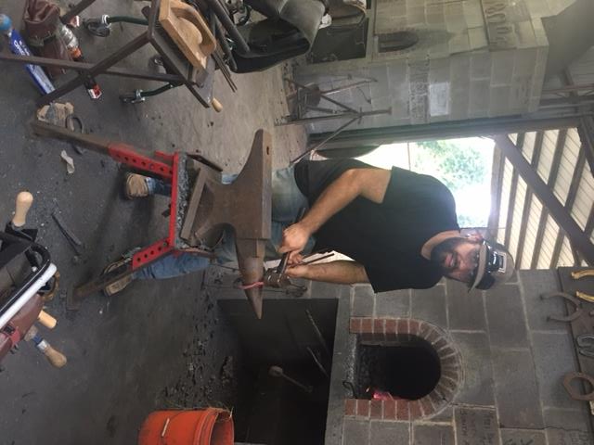
It is in the same spirit that the Edward Martin Perpetual Competition is held every September at the Draft Horse Classic in Grass Valley, CA. Following the same guidelines as in the Closeburn contest, competitors shoe draft horses’ using hot coke forges to build shoes from straight bar stock. Sparks fly and smoke boils as a line of horses are shod against the clock.

We wish Virgilio every success as he pursues his studies in the world of farriery.

For more for more information about the Edward Martin Perpetual Competition or Scholarship Fund contact: Bill Merfy, CJF fortwm@succeed.net, (702) 217-7366

# # #

